Name _________________________________ Date _____________________ Block # ______
Mitosis Activity Worksheet
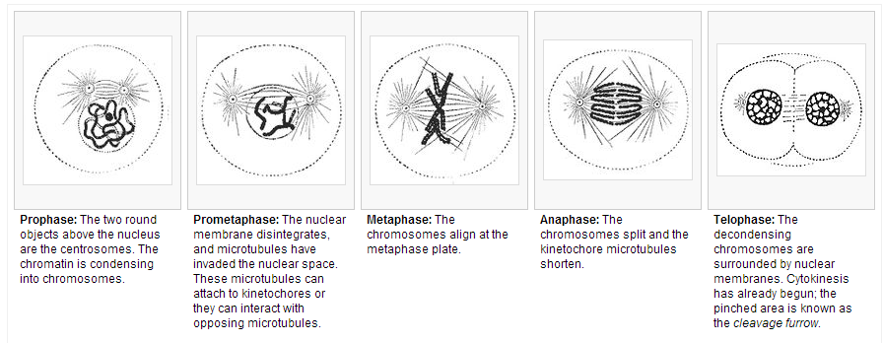
Directions: Analyze the photo of onion cells. Use the below table to classify how many cells are in each phase; you will then create a bar graph.

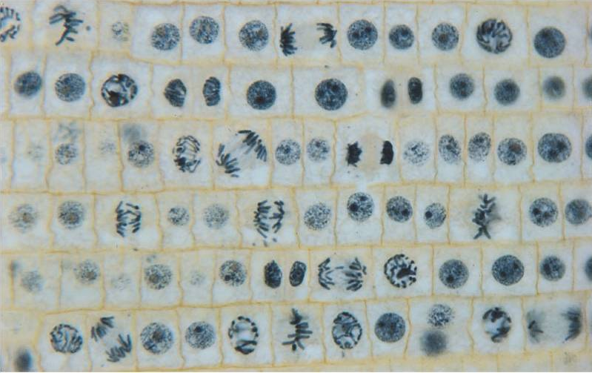

Phase | Tally | Total | % of Time in Phase
Interphase
Prophase
Metaphase
Anaphase
Telophase
Cytokinesis

Number of Cells
Stage of Cell Cycle

